Institute of Computer And Technology

B.Tech – CSE(BDA)

Name:-Anik Shaikh

Sem:-2

Sub:-Database Management

Enrollment No.:-23162121021

Prac:-1

Date:-29 /7/2024

Practical 1

1. Create database in mysql with your branch name and enrollment number.

Query:

create table Client_master (Client_no varchar(10), Name varchar(20), City varchar(20), Pincode int, State varchar(20), Bal_due int);

Screenshots:-

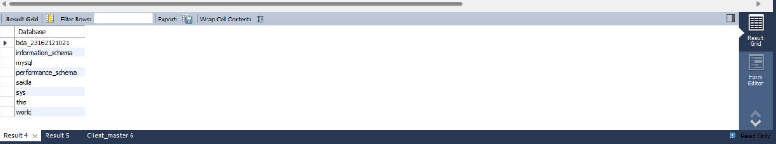

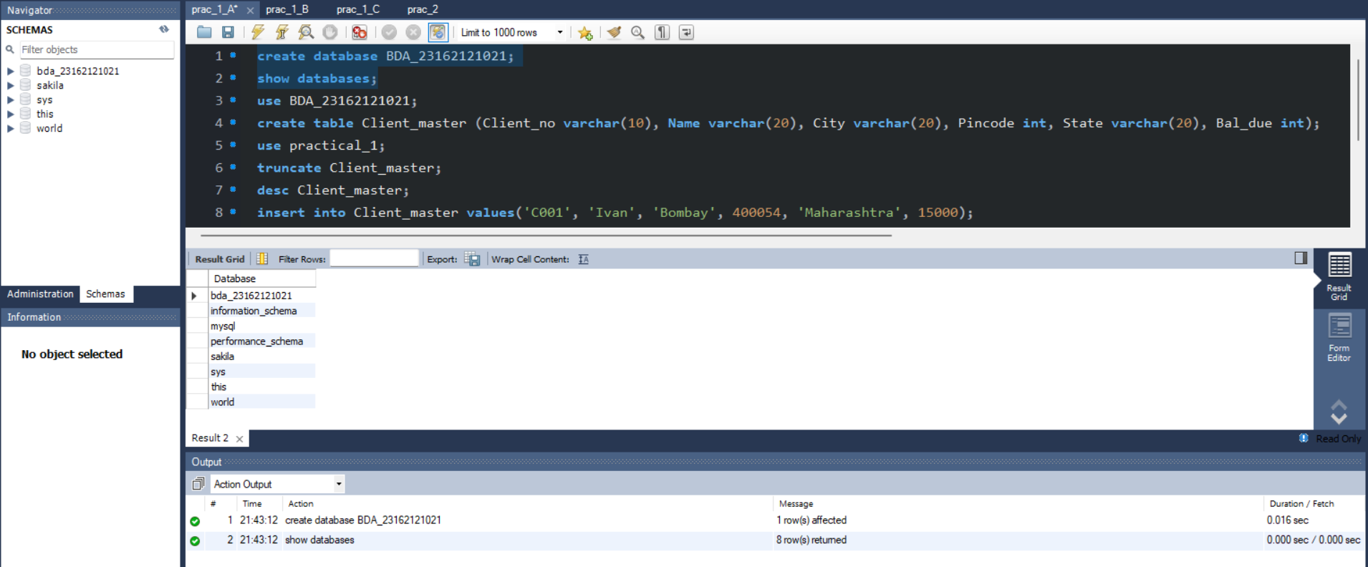

1. Create table client_master.

Query:

create table Client_master (Client_no varchar(10), Name varchar(20), City varchar(20), Pincode int, State varchar(20), Bal_due int);

Screenshots:-

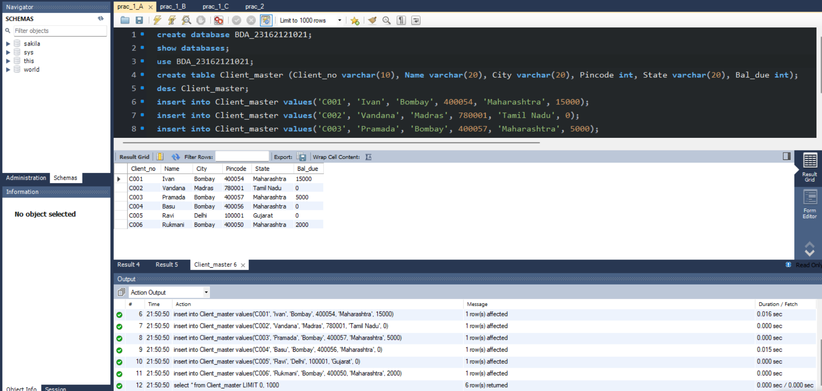

1. Create table product_master.

Query:

create table Product_master (Product_no varchar(10), Description varchar(20), P_percent varchar(10), U_measure varchar(20), Qty_on_hand int, Reorder_lvl int, sell_price int, Cost_price int);

Screenshot:-

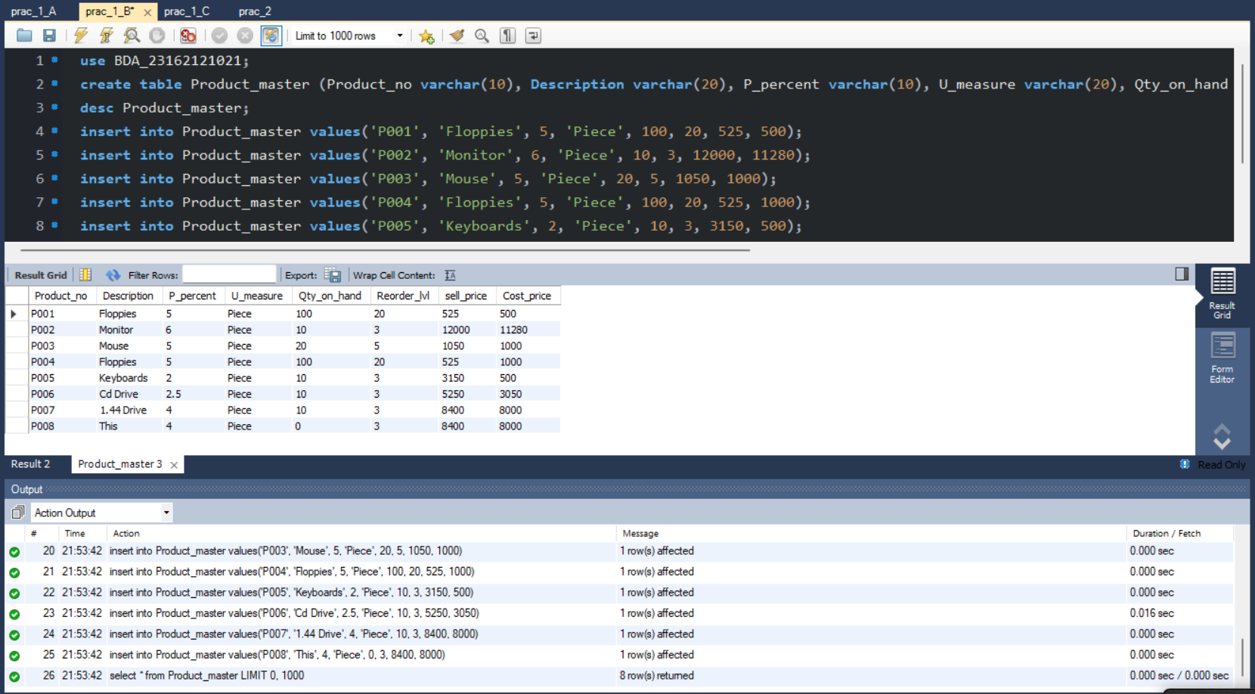

1. Create table Salesman_master.

Query:

create table Salesman_master (S_no varchar(10), S_name varchar(20), City varchar(20), Pin int, State varchar(20), Sal_Amt int, Tgt_to_get int,Ytd_sales int, Reamrks varchar(20));

Screenshot:-

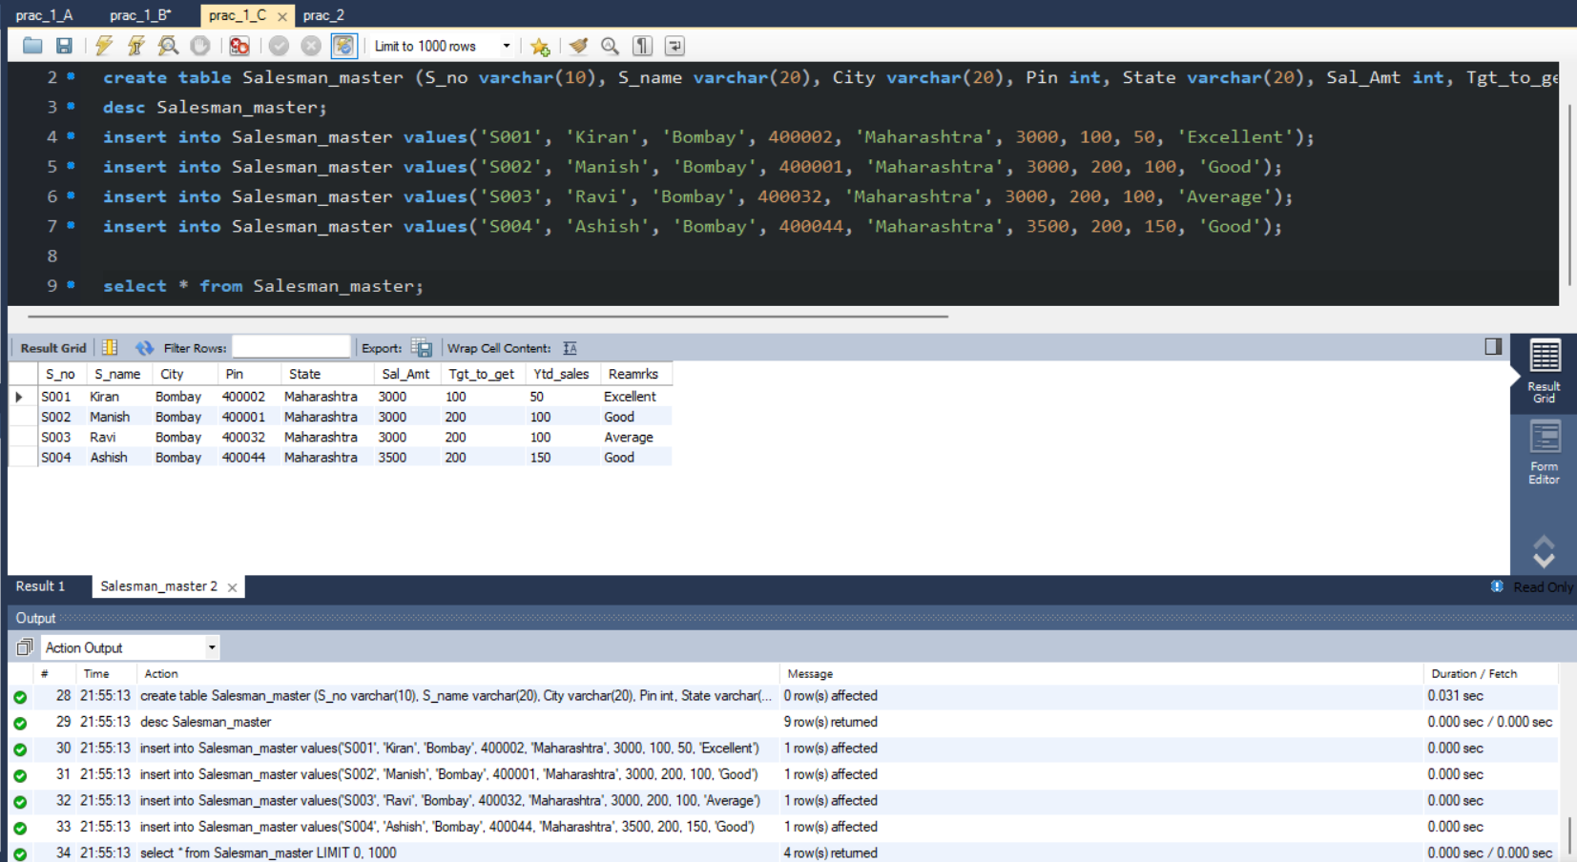

1. Describe structure for client_master table.

query :

desc table client_master;

Screenshot:-

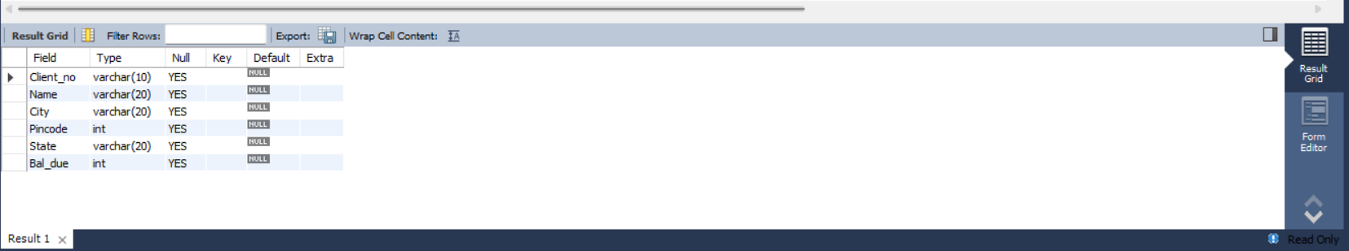

1. Describe structure for product_master table. Query: desc table product_master;

Screenshot:-

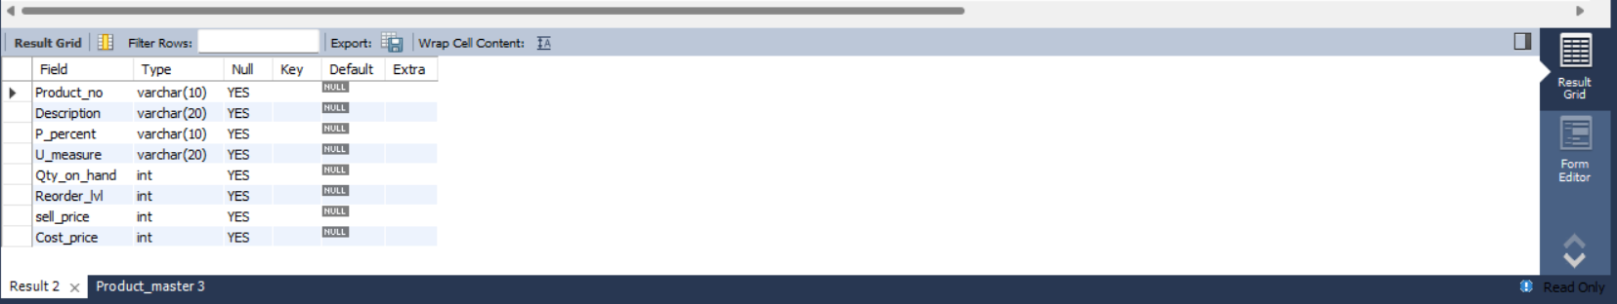

1. Describe structure for salesman_master table. Query: desc table salesman_master;

Screenshot:-

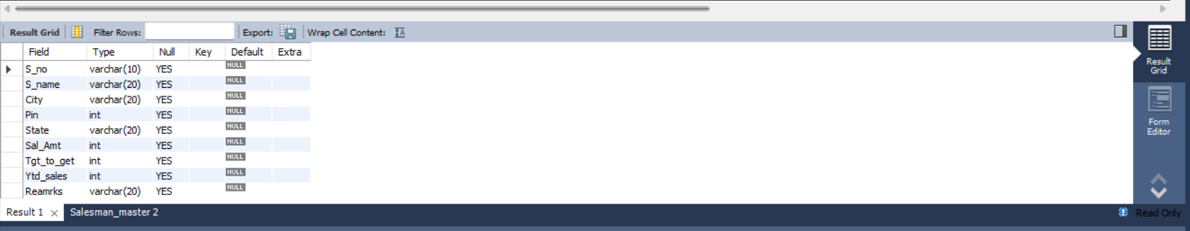

1. Insert records in client_master table.

Query:

insert into Client_master values('C001', 'Ivan', 'Bombay', 400054, 'Maharashtra', 15000);

insert into Client_master values('C002', 'Vandana', 'Madras', 780001, 'Tamil Nadu', 0);

insert into Client_master values('C003', 'Pramada', 'Bombay', 400057, 'Maharashtra', 5000);

insert into Client_master values('C004', 'Basu', 'Bombay', 400056, 'Maharashtra', 0);

insert into Client_master values('C005', 'Ravi', 'Delhi', 100001, 'Gujarat', 0);

insert into Client_master values('C006', 'Rukmani', 'Bombay', 400050, 'Maharashtra', 2000);

Screenshot:-

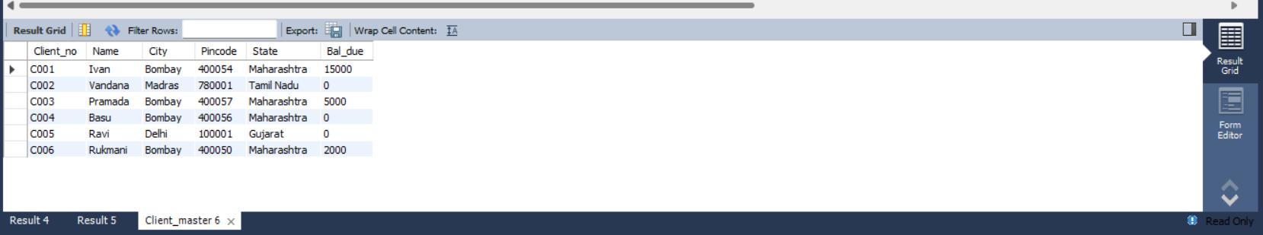

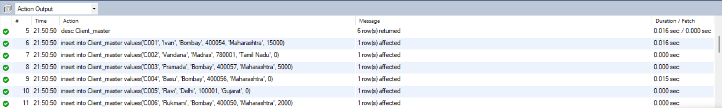

1. Insert records in product_master table.

Query:

insert into Product_master values('P001', 'Floppies', 5, 'Piece', 100, 20, 525, 500);

insert into Product_master values('P002', 'Monitor', 6, 'Piece', 10, 3, 12000, 11280);

insert into Product_master values('P003', 'Mouse', 5, 'Piece', 20, 5, 1050, 1000);

insert into Product_master values('P004', 'Floppies', 5, 'Piece', 100, 20, 525, 1000);

insert into Product_master values('P005', 'Keyboards', 2, 'Piece', 10, 3, 3150, 500);

insert into Product_master values('P006', 'Cd Drive', 2.5, 'Piece', 10, 3, 5250, 3050);

insert into Product_master values('P007', '1.44 Drive', 4, 'Piece', 10, 3, 8400, 8000);

insert into Product_master values('P008', 'This', 4, 'Piece', 0, 3, 8400, 8000);

Screenshot:-

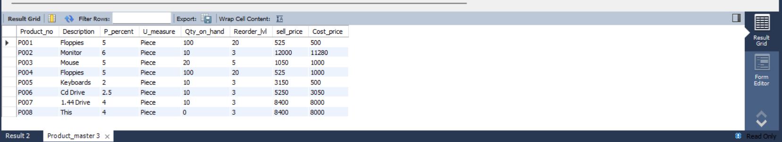

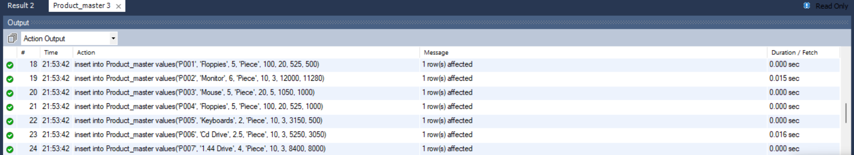

1. Insert records in salesman_master table.

Query :

insert into Salesman_master values('S001', 'Kiran', 'Bombay', 400002, 'Maharashtra', 3000, 100, 50, 'Excellent');

insert into Salesman_master values('S002', 'Manish', 'Bombay', 400001, 'Maharashtra', 3000, 200, 100, 'Good');

insert into Salesman_master values('S003', 'Ravi', 'Bombay', 400032, 'Maharashtra', 3000, 200, 100, 'Average');

insert into Salesman_master values('S004', 'Ashish', 'Bombay', 400044, 'Maharashtra', 3500, 200, 150, 'Good');

Screenshot:-

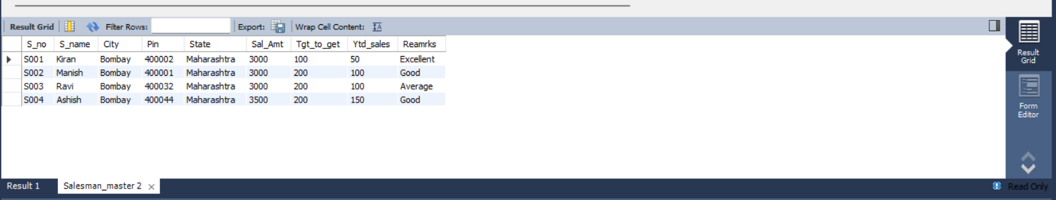

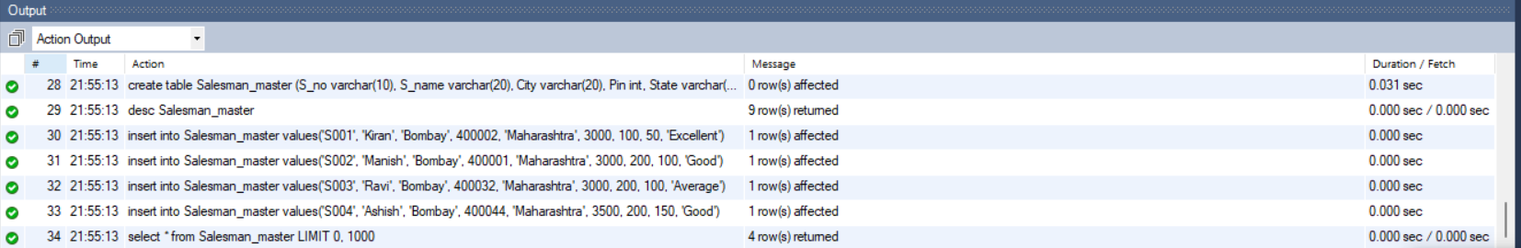

1. Retrieve all records for client_master table.

Query:-

select * from client_master;

Screenshot:-

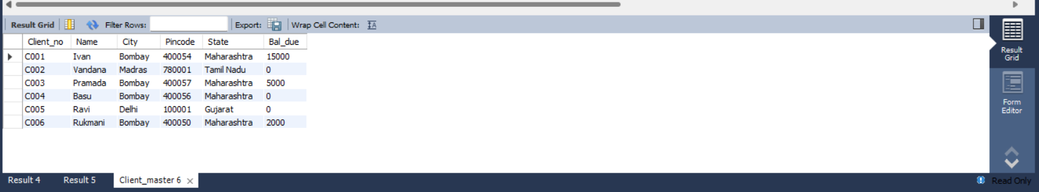

1. Retrieve product_no, sell_price and cost_price for product_master table

Query: select product_no, sell_price, cost_price from product_master

Screenshot:-

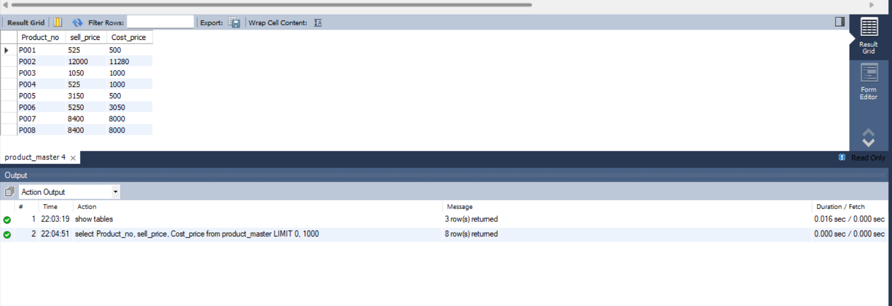

1. Retrieve s_no,s_name, remarks and sal_amt for salesman_master table.

Query: select s_no, s_name, remarks, sal_amt from salesman_master;

Screenshot:-

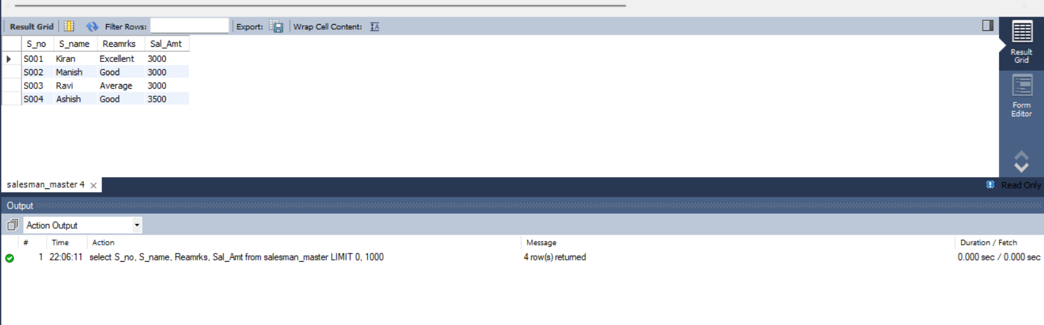

1. Display all tables for your database.

Query:

show tables;

Screenshot:-

